Kapitza-Dirac effect with lasers and non-resonant interaction for quantum modulation of electron beams (Schwarz-Hora effect)

Heinrich Hora^{1a,b)} and Peter H. Handel^{a)}

¹Department of Theoretical Physics, University of New South Wales, Sydney 2052, Australia
²Department of Physics, University of Missouri at St. Louis, St. Louis, Missouri 63121, USA

Abstract: The initial Kapitza-Dirac effect for crossing energetic electron beams with laser beams had been generalized for quantum modulation of the electrons. The recent developments provide advanced insights with the initial experimental facts where consequences are leading to results about non-resonant laser interaction with condensed media including nonlinearities with applications to quantum 1/f noise theory in electronic devices.

Key words: Laser Interaction with electron beams; Kapitza-Dirac effect; Schwarz-Hora effect; non-resonant nonlinear excitation; virtual electron states.

- H. Hora and P.H. Handel, equal contributors
- E-mail h.hora@unsw.edu.au

The final detailed experimental demonstration¹ of the Kapitza-Dirac effect² for scattering of an electron beam when crossing a laser beam by standing wave nodes and antinodes is related to the basic understanding of laser interaction with electrons. This refers to both, to electrons in the unbound-free state in vacuum and also in high temperature plasmas, as well as to electrons in the bound states in a condensed medium. For the free electrons, the Kapitza-Dirac effect – now demonstrated¹ - is a very early² theoretical approach to the problem of nonlinearity which came later into the focus of attention with the laser. The question of the electron interaction in the bound state was touched by quantum modulation effect³ where a condensed medium was located into the crossing area of the beams as a generalization of the Kapitza-Dirac effect. This generalization did realize from the beginning that this is a quantum modulation process³ for the electron beam.
At the time when the measurement of the quantum modulation by using crystals as medium³ and the repetition of the experiments and reproduction of the effect with molecules as medium^{4,5} were performed, the nonlinearity of the interaction process was just at the begin to be clarified. This question was opened by realizing that the interaction of electrons with lasers could not happen by linear physics but needed nonlinear physics⁶. Before, the linear description was based on the exactly derived result that a free electron can never gain energy⁷ from a laser field of a plane wave electromagnetic pulse. In contrast, after realizing the nonlinearity, acceleration of free electrons by lasers can produce beams of measured GeV energy and may lead to beams with PeV electrons using Exawatt (EW) laser pulses in the range of femtosecond (fs) duration⁸.
The Kapitza-Dirac effect was predicted in 1933 for the interaction of electron beams with optical beams in a modified way going beyond the knowledge of linear interaction. In view of these facts, the following clarifies the position of the quantum modulation process under the aspect of the Kapitza-Dirac experiment¹. For the quantum modulation, in the first part, the results about the long beating wave length of the electrons and the fit with the theory of Peierls⁹ is shown, then the agreement of the initial quantum model³ is supported by the later performed quantum modulation experiments of Weingartshofer et al.⁵, and finally an updating of the early reported consequences¹⁰ to the 1/f noise theory for applications to electronics elements is presented.
Clarification of the long wave length beating. The initial experiment demonstrated the scattering of the electrons³ if a crystal in the crossing area of the electron beam with a transport of photons to a nonluminescent screen. The modulation of the photons in the electron beam was directly shown with a neon laser interacting with argon atoms using a CO₂ laser to show an up- or down shift of the electron energy by the laser photons as measured in the electron energy spectrum⁴. The first experiment³ was leading to the measured long wave length beating¹¹ for demonstration of the effect. This is different to the later demonstration of the effect by using and argon atoms in the crossing area where the modulation could be directly measured from the electron spectrum with the shift of the energy ħω by the energy of photons of the laser with the frequency ω^{5,6} using Planck’s constant h and ħ=h/2π.
Following the initial publication³, the beating in the electron beam¹² was studied. In first order, electron and light waves show the same beating for which the necessary coherence is fulfilled¹³. In contrast for electron waves, the second order showed a basic difference to optical waves. This was used before e.g. to calculate exact solutions for the Goos-Haenchen effect^{14,15} while the optical case could be treated only by approximations. Salat discovered a second order bunching for electrons¹³ having a wave length λ_{e}

Λ_{beo} = 8λ_{e}(E_{o}/ ħω)² = 1.6858 cm (1)

When Schwarz got the paper for refereeing, he immediately used his experiment with motion of the non-luminescent screen and measured this second order bunching¹¹, Fig. 1 with a wave length

Λ_{be} = 1.73(0.01) cm. (2)

The theory¹² was 3% lower than the measured long beating wave length. The computation was non-relativistic. A relativistic approximation¹⁶ arrived even at a shorter wave length 1.51 cm. This raised questions to the experiment of Schwarz. Using an exact derivation with the Dirac equation for the electrons¹⁷, the problem was what dielectric response should be applied for the crystals used by Schwarz^{3,11}. An initially used dispersion led still to a difference with the experiment. When the later theory of Peierls⁹ arrived at the ratio of the speed of light c_{M} in the medium with a refractive index n = 1.58 of the crystal and the speed of light in vacuum c

c_{M}/c = (n² -1)[1 + (n² - 1)/5]/n, (3)

the theoretical long beating wave length was

Λ = 1.740 cm. (4)

This exact fit was an immediate proof of the correctness of the Peierls⁹ theory and also confirmed the very accurate measurement of the motion of the non-luminescent screen by Schwarz¹¹.
Theory of quantum limit. The initial paper on the Schwarz-Hora effect³ included a rather obvious but nevertheless hypothetical theoretical assumption. When the electrons of the beam are moving through the condensed medium (crystal or molecules), will they interact with the laser field as if they are free electrons, as being in vacuum or in a high temperature plasma? Or will there be an interaction with the electrons in the medium? In the first case, the electrons are picking up oscillations in the laser field and returning this "quiver energy" when leaving the laser field, independently from any polarization direction. This corresponds to the exact theoretical solution requiring that free electrons in a laser field should not absorb optical energy or receive an acceleration⁷ based on linear theory. It changes by inclusion of nonlinear effects. Energy from a laser field to free electrons can be transferred by nonlinear mechanisms⁶ as well known now from electron acceleration in laser fields^{6,18}. The fact that energy from laser photons is exchanged with the electrons within a medium³⁻⁵ can only happen by inclusion of nonlinear processes within the medium. Its electrons, however are not free and assuming that these behave in a similar way as free electrons can be considered only as a hypothetical virtual process.
Such virtual motion is considered similar to that of free electrons. One obtains then a displacement x along the direction of the electric field E, determined by the laser intensity I of the laser for the oscillation and maximum momentum p = m(dx/dt). It was postulated³ that if xp is less than ħ this should be a range of quantum interaction and if larger than ħ it should be classical. The laser intensity I between these two ranges, expressed in a modified formulation³ using the fine structure constant α

I = I* = mω³/(8πα) = π²mc³/(αλ³), (5)

Where λ is the laser wave length. Converting (5) from cgs units to Watts/cm² results for CO₂ lasers in

I* = 1.403x10⁹ W/cm² (6)

For cw lasers in the experiments, this condition is fulfilled with intensities I < I* within the quantum range³ both for argon lasers and the subsequent experiments with^{4,5} CO₂ lasers.
It was interesting, to measure the scattering intensity of the modulation effect from the electron spectra by varying the laser intensity. Fig. 2 shows a typical results of Weingartshofer et al.⁵. From a series of experiments the strength of the modulation can be evaluated as shown in Fig. 3 resulting in a decrease of the scattering intensity with increasing laser intensity I, down to no scattering when reaching the threshold intensity I* of Eq. (6). This is a proof of the correct conditions of Weingartshofer’s et al. rather sophisticated experiments, and of the intensity threshold I* with the limit of the quantum range towards the classical range demonstrated for the basic use in initial experiments³ and the ones following^{4,5}.
Interpretation and application to 1/f noise. After the final experimental establishment and demonstration of the Kapitza-Dirac effect¹, this is also proof of its generalization by adding a medium in the crossing area, when crossing an electron beam with the laser beam (Schwarz-Hora effect)³⁻⁵. What is remaining is the further understanding of the non-resonance of the medium aspect and the necessary involvement of the medium that provides the essential nonlinear mechanism. This can be realized on the basis of achievements, during the recent years, in the theory of target interactions with a laser field. In linear physics, the exact solution did not permit a final energy transfer from a laser beam to an electron in vacuum. In contrast, the basic new result was⁶ that nonlinearity resulted in electron acceleration in laser fields in vacuum, that now has been achieved^{8,18}. A connection exists, and is mentioned here, to the quantum mechanical theory of the fundamental 1/f noise^{10,.19,20} and to quantum coherence²¹.
For the fundamental understanding of quantum mechanics it has to be realized that the interaction is a non-resonance process differing from the well-known optical resonances in the medium. Heisenberg aimed to base quantum mechanics purely on observable quantities, such as the exactly measured energy levels of spectral lines. He connected these levels with matrix elements of non-commutative operators to elegantly obtain quantization. Together with Dirac and others he defined Poisson brackets and also described the hydrogen atom relativistically, recovering line shift of fine structure, predicting antimatter and more. This was a method with directly and transparently observed quantities. The way introduced by Schrödinger, following DeBroglie's result with wave functions Ψ, was more indirect. It obtained the same results through solutions of differential equations, from eigenvalues of spherical functions and Laguerre associated functions. This was a quite transparent treatment for the hydrogen atom. The wave functions Ψ however were not directly observable values of measurements, but only indirect expressions of distribution functions from where the real observable values of measured quantities had to be derived as expectation values.
Dirac mentioned some incompleteness in quantum mechanics²². The absence of a matrix element in Quantum Electro Dynamics QED due to the long range of the Coulomb potential was an incompleteness that was removed by the introduction²³ of the long range Coulomb interaction into the unperturbed hamiltonian. It led to a more complex notion of a free charged particle of indefinite energy that is never exactly free, with its field in a non-stationary coherent state, and with the asymptotic QED propagator^{27,28} of Faddeev, Kulish, Zwanziger and Kibble for large times or low frequencies. This non-stationarity with implicit de-coherence allowed us to explain^{10.26,27} the ubiquitous fundamental 1/f noise with the simple universal formula 2α/πfN for the spectral density of fractional fluctuations of current carried by N charge carriers. It brought us a new basic aspect^{28,29} of quantum physics, with new notions of "physical" cross sections and process rates that still contain the mezo/macroscopic "infrared" genuine quantum fluctuations, with great practical importance in the optimization of most hi-tech applications^{29,30}, for ultra-low 1/f noise and phase noise close to carrier. It is applicable with coherent and conventional contributions for any system of quanta with infrared-divergent coupling to any current, including also gravitons, transversal piezo- phonons, etc., by just replacing the fine structure constant a with the right coupling constant. For nanotechnology applications and devices the conventional part is dominant.
On the other hand, the example of non-resonance and the principle realization of nonlinearity³¹ for the electron beam interaction with laser photons occurring in condensed media within the defined quantum range for the laser intensity I < I* may also be one avenue to access exploring more subtle properties of these processes.

References:
1. D.L. Freimund, K. Aflatooni & H. Batelaan H. Nature, 413, 142-143 (2001)
2. P.L.,Kapitza & P.A.M. Dirac Proc. Camb. Phil. Soc., 29, 297-300 (1933)
3. H. Schwarz H., & H. Hora Appl. Phys. Letters 15, 349-351 (1969)
4. D. Andrick & L. Langhans L. J. Phys. B 11, 2355-2359 (1978)
5. A. Weingartshofer, J.K. Holmes, J. Sagabah & S.L. Jin J. Phys. B 16, 1805 (1985)
6. H. Hora Nature 333, 337-338 (1988)
7. A. Sessler Am. J. Phys. 54, 505 (1986)
8. G. Mourou & C. Labaune, 50 years Laser Conference Paris 23 June 2011. DVD Laboratoire d’Optique Applicee, ENSTA Palaisseau Cedex, France 2011
9. R. Peierls Proc. Roy. Soc. Edinburgh A 347, 475 (1976)
10. Hora H., &. Handel P.H. New Experiments and theoretical development of the Quantum Modulation of Electrons (Schwarz-Hora effect), Advances in Electronics and Electron Physics, Hawkes P.W. ed. (Acad. Press, New York, 1987) 69, 55-113.
11. H. Schwarz H. Trans. New York Acad. Sci. 33, 130 (1971)
12. A. Salat J. Phys. C 3, 2509 (1970)
13. H. Hora Physica Status Solidi 42, 131-136 (1970).
14. H. Hora Optik 17, 409-415 (1960).
15. J.L. Carter & H. Hora J. Opt. Soc. Amer. 61, 1640-1645 (1971).
16. L.L. Van Zandt & J.W. Meyer. J. Appl. Physics 41, 4470-4475 (1970)
17. H. Hora Physica Status Solidi 80, 143 (1977)
18. H. Hora, M. Hoelss, W. Scheid, J.X. Wang, Y.K. Ho Y.K., F. Osman & R. Castillo Laser and Particle Beams, 18, 135-144 (2000)
19. P.H. Handel Phys. Rev. A22, 745-748 (1980).
20. A. Van der Ziel, A.D. van Rheenen & A.N. Birbas Phys. Rev. B40, 1806-1809 (1989).
21. P.H. Handel Phys. Rev. A38, 3082-3085 (1988).
22. P.A.M. Dirac Directions in Physics (H. Hora & J.R. Shepanski eds.) John Wiley, New York (1978)
23. P.H. Handel Phys. Rev. A38, 3082-3085 (1988)
24. P.P. Kulish, & L.D. Faddeev, Theor. Mat. Phys. (USSR) 4, 745 (1971).
25. D. Zwanziger, Phys. Rev. D7, 1082 (1973); Phys. Rev. Lett. 30, 934 (1973); Phys. Rev. D11, 3481 and 3504 (1975)
26. P.H. Handel, IEEE Trans. on Electr. Devices 41, 2023-2033 (1994).
27. P.H. Handel, Phys. Rev. Letters 34, p.1492-1494 (1975)
28. P.H. Handel “Noise, Low Frequency”, Wiley Encyclopedia of Electrical and Electronics Engineering, vol. 14, pp. 428-449, John Wiley & Sons, Inc., John G. Webster, Editor, 1999.
29. P.H. Handel and A.G. Tournier, IEEE 93, 1784-1814 (2005).
30. T.F. George and P.H. Handel, J. of Modern Physics B, World Scientific Publishing Co. Vol. 20, Nos. 11-13, pp 1343-1362 (2006).
31. H. Hora, H. Laser Plasma Physics: interaction forces and the nonlinearity principle. The International Society for Optical Engineering SPIE, Bellingham WA (2000)

Figure Captions

Fig. 1. Optical emission intensity from the non-luminescent screen³ for varying the distance D = r between crystal and screen¹⁴. The minima correspond to the long beating wave length according to Eq. (3).
Fig. 2. Schwarz-Hora effect measured by Weingartshofer et al.⁵ (from Fig. 5 of Ref.⁵) of the energy spectrum of the electron beam after interaction from where the height of the intensity of the scattered first maximum could be related to that of the incident laser intensity I, see following Fig. 3 with cases A, B and C for different laser intensities an no laser, D.

Fig. 3. Measured intensity ratios of the scattered radiation of the electrons⁵ on the irradiated CO₂ laser intensity I decaying to zero at the threshold intensity I*, Eq. (6), separating quantum interaction (I < I*) from the classical case (I > I*) defining a correspondence principle for electromagnetic interaction.

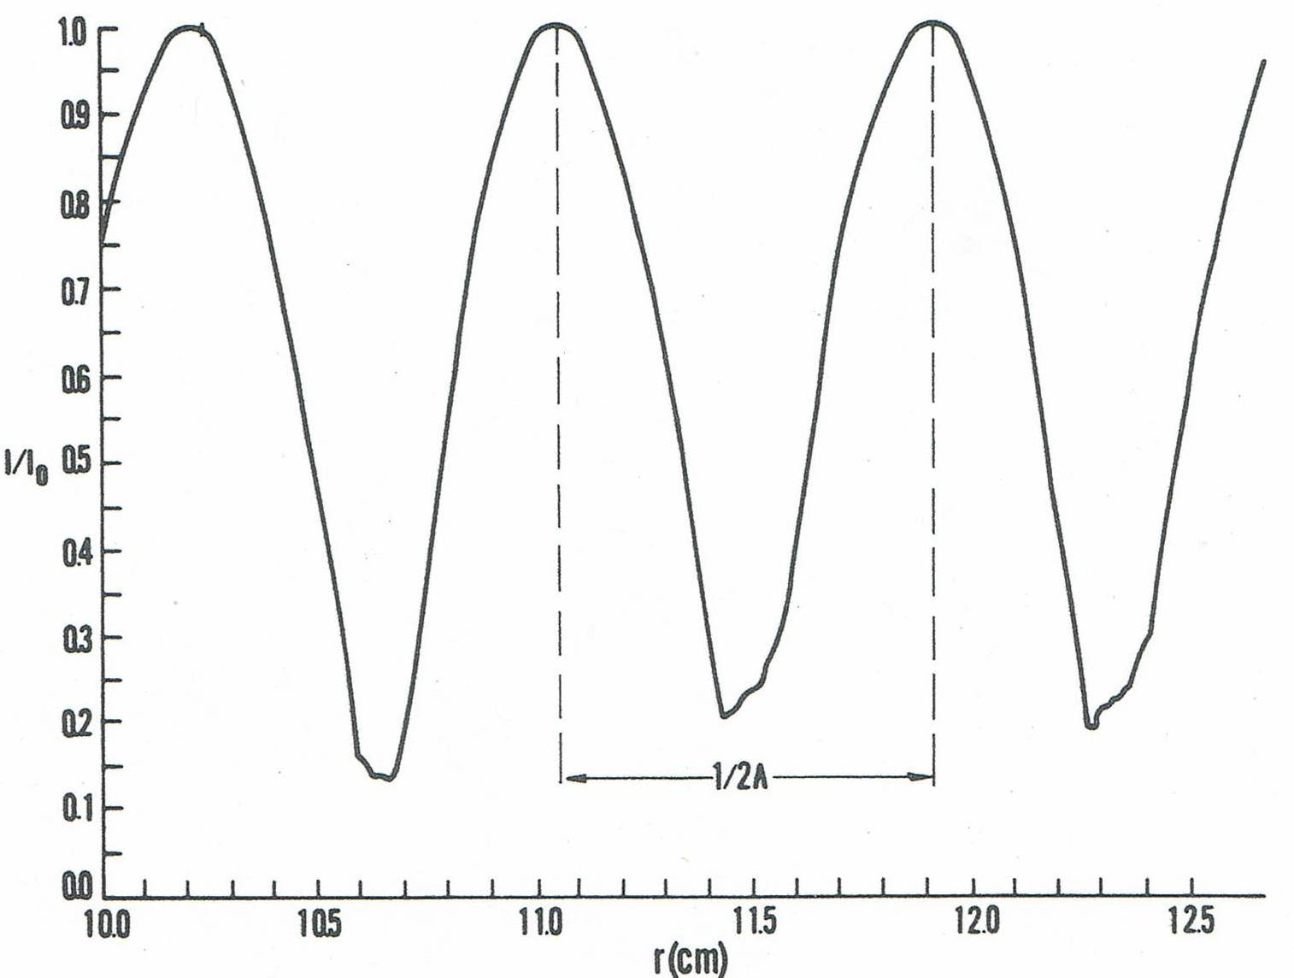

Fig. 1

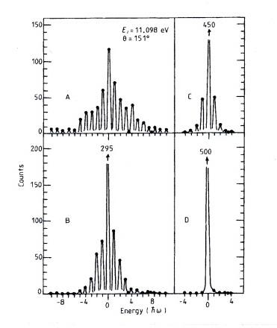

Fig. 2

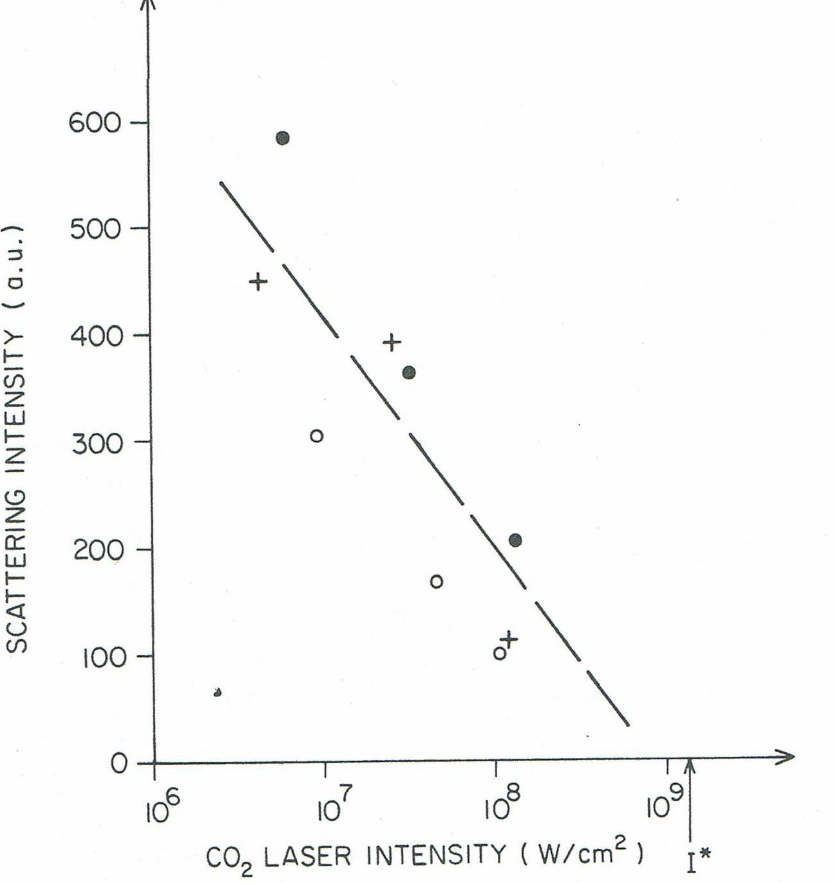

Fig. 3

